Mini E-Commerce Product Billing System
Department: Computer Science & Engineering
1. Project Description
The Mini E-Commerce Product Billing System is a console application designed to handle shop catalogs, item orders, checkout quantities, automated discount rules, and customer bills. It provides an operational interface for administrators to manage stock files and a dynamic shopping workspace for customers built on robust data security guidelines.
2. Objectives
The system focuses on creating clear object classes representing products and shopping baskets, using STL vectors to avoid hardcoded boundaries, implementing file handling routines for permanent catalog state storage, and executing automated conditional structures for tier-based customer discount calculations.
3. Software Requirements
Operating System: Windows 10/11, Linux, or macOS
Compiler Standard: C++11 or higher (GCC / G++ or MSVC Toolchain)
Development Tools: Visual Studio Code, Code::Blocks, or terminal editors
4. Concepts Used
Object-Oriented Programming (OOP): Blueprint classes handling entities like Product or CartItem.
Standard Template Library (STL) Vectors: Dynamic vector containers for volatile memory tracking.
File Handling (fstream): Input and output file streams ensuring data persistence across restarts.
Stream Manipulators (iomanip): Formatting data columns for perfect tabular alignment across terminal blocks.
5. Algorithm
- On system boot, read 'inventory.txt' via comma tokenization and populate the product vector container.
- Display a terminal gate supporting Admin login authentication, Customer entrance, and system shutdowns.
- Admin mode validates the authorization passphrase. If successful, it allows product registration with unique item ID validations.
- Customer workspace allows live product browsing, shopping basket updates with rigid stock validation, and final checkout.
- The checkout module calculates a subtotal, evaluates tier discount rates (5% over Rs. 1000, 10% over Rs. 2000, 15% over Rs. 5000), exports the receipt into a file using Unix timestamp IDs, and updates stock logs.
6. Source Code
#include <iostream>
#include <vector>
#include <fstream>
#include <string>
#include <iomanip>
#include <ctime>

using namespace std;

// Class representing a product in the shop inventory
class Product {
public:
int id;
string name;
double price;
int stock;

Product(int i, string n, double p, int s) : id(i), name(n), price(p), stock(s) {}

// Converts product fields into a comma-separated format for file storage
string toFileData() const {
return to_string(id) + "," + name + "," + to_string(price) + "," + to_string(stock);
}
};

// Class representing an item inside the customer's shopping cart
class CartItem {
public:
int id;
string name;
double price;
int quantity;

CartItem(int i, string n, double p, int q) : id(i), name(n), price(p), quantity(q) {}
};

// Main system controller managing inventory, cart sessions, authentication, and files
class BillingSystem {
private:
vector<Product> inventory;
vector<CartItem> cart;
const string inventoryFile = "inventory.txt";

// Internal helper to parse database file on app startup
void loadInventory() {
inventory.clear();
ifstream file(inventoryFile);
if (!file.is_open()) return;

string line;
while (getline(file, line)) {
size_t pos1 = line.find(',');
size_t pos2 = line.find(',', pos1 + 1);
size_t pos3 = line.find(',', pos2 + 1);

if (pos1 != string::npos && pos2 != string::npos && pos3 != string::npos) {
int id = stoi(line.substr(0, pos1));
string name = line.substr(pos1 + 1, pos2 - pos1 - 1);
double price = stod(line.substr(pos2 + 1, pos3 - pos2 - 1));
int stock = stoi(line.substr(pos3 + 1));
inventory.push_back(Product(id, name, price, stock));
}
}
file.close();
}

// Internal helper to commit changes back to data file
void saveInventory() {
ofstream file(inventoryFile);
for (const auto& prod : inventory) {
file << prod.toFileData() << "\n";
}
file.close();
}

public:
BillingSystem() {
loadInventory();
}

// Admin Verification System
bool authenticateAdmin() {
string username, password;
cout << "\n================= ADMIN LOGIN =================\n";
cout << "Enter Admin Username: ";
cin >> username;
cout << "Enter Admin Password: ";
cin >> password;

if (username == "admin" && password == "admin123") {
cout << " Access Granted! Welcome back, Admin.\n";
return true;
} else {
cout << " Invalid Credentials! Access Denied.\n";
return false;
}
}

// ADMIN MODE: Stock Registration
void addNewProduct() {
int id, stock;
string name;
double price;

cout << "\nEnter Product ID: ";
cin >> id;

for (const auto& prod : inventory) {
if (prod.id == id) {
cout << " Error: Product ID already exists!\n";
return;
}
}

cout << "Enter Product Name: ";
cin.ignore();
getline(cin, name);
cout << "Enter Price: Rs. ";
cin >> price;
cout << "Enter Initial Stock Quantity: ";
cin >> stock;

inventory.push_back(Product(id, name, price, stock));
saveInventory();
cout << " Product successfully recorded in inventory!\n";
}

// CUSTOMER & ADMIN MODE: Display Live Catalog
void viewInventory() {
if (inventory.empty()) {
cout << "\n Store catalogs are empty right now.\n";
return;
}

cout << "\n================ AVAILABLE PRODUCTS ================\n";
cout << left << setw(10) << "ID" << setw(20) << "Name" << setw(15) << "Price (Rs.)" << setw(10) << "Stock" << "\n";
cout << "----------------------------------------------------\n";
for (const auto& prod : inventory) {
cout << left << setw(10) << prod.id
<< setw(20) << prod.name
<< "Rs. " << setw(11) << fixed << setprecision(2) << prod.price
<< setw(10) << prod.stock << "\n";
}
cout << "====================================================\n";
}

// CUSTOMER MODE: Add products into dynamic session vector
void addToCart() {
if (inventory.empty()) {
cout << "\n No items available to buy!\n";
return;
}

int id, qty;
cout << "\nEnter Product ID to add: ";
cin >> id;

for (auto& prod : inventory) {
if (prod.id == id) {
cout << "Enter Quantity: ";
cin >> qty;

if (qty < 0 || qty == 0) {
cout << " Invalid quantity value!\n";
return;
}
if (qty > prod.stock) {
cout << " Insufficient stock allocation! Only " << prod.stock << " remaining.\n";
return;
}

prod.stock -= qty;

bool foundInCart = false;
for (auto& item : cart) {
if (item.id == id) {
item.quantity += qty;
foundInCart = true;
break;
}
}
if (!foundInCart) {
cart.push_back(CartItem(prod.id, prod.name, prod.price, qty));
}

saveInventory();
cout << "🛒 Successfully added " << qty << " units of " << prod.name << " to cart!\n";
return;
}
}
cout << " Requested Product ID not found!\n";
}

// CUSTOMER MODE: Print console bill + write customized persistent text file
void generateFinalBill() {
if (cart.empty()) {
cout << "\n🛒 Processing halted: Shopping cart is empty!\n";
return;
}

double subtotal = 0.0;

// Dynamic, unique timestamp creation for independent receipt files
time_t now = time(0);
string receiptFileName = "Receipt_" + to_string(now) + ".txt";

ofstream receipt(receiptFileName);

// Header definitions for console stream
cout << "\n=================== FINAL INVOICE ===================\n";
cout << left << setw(20) << "Item Name" << setw(12) << "Price" << setw(10) << "Qty" << setw(12) << "Total" << "\n";
cout << "-----------------------------------------------------\n";

// Header definitions for active output file stream
receipt << "=================== TRANSACTION RECEIPT ===================\n";
receipt << "Timestamp ID: " << now << "\n";
receipt << "-----------------------------------------------------------\n";
receipt << left << setw(20) << "Item Name" << setw(12) << "Price" << setw(10) << "Qty" << setw(12) << "Total" << "\n";
receipt << "-----------------------------------------------------------\n";

for (const auto& item : cart) {
double itemTotal = item.price * item.quantity;
subtotal += itemTotal;

// Output data stream running side by side
cout << left << setw(20) << item.name << "Rs. " << setw(8) << fixed << setprecision(2) << item.price << setw(10) << item.quantity << "Rs. " << itemTotal << "\n";
receipt << left << setw(20) << item.name << "Rs. " << setw(8) << fixed << setprecision(2) << item.price << setw(10) << item.quantity << "Rs. " << itemTotal << "\n";
}

// Tiered Discount calculations
double discountPercent = 0.0;
if (subtotal > 5000) discountPercent = 15.0;
else if (subtotal > 2000) discountPercent = 10.0;
else if (subtotal > 1000) discountPercent = 5.0;

double discountAmount = subtotal * (discountPercent / 100.0);
double finalBill = subtotal - discountAmount;

// Terminal Block output
cout << "-----------------------------------------------------\n";
cout << left << setw(42) << "Subtotal:" << "Rs. " << subtotal << "\n";
cout << left << setw(42) << ("Discount (" + to_string((int)discountPercent) + "%):") << "-Rs. " << discountAmount << "\n";
cout << "=====================================================\n";
cout << left << setw(42) << "GRAND TOTAL TO PAY:" << "Rs. " << finalBill << "\n";
cout << "=====================================================\n";
cout << "✨ Bill settled. Receipt written to disk as: " << receiptFileName << "\n\n";

// File generation summary block
receipt << "-----------------------------------------------------------\n";
receipt << left << setw(42) << "Subtotal:" << "Rs. " << subtotal << "\n";
receipt << left << setw(42) << ("Discount (" + to_string((int)discountPercent) + "%):") << "-Rs. " << discountAmount << "\n";
receipt << "===========================================================\n";
receipt << left << setw(42) << "GRAND TOTAL PAID:" << "Rs. " << finalBill << "\n";
receipt << "===========================================================\n";
receipt << " ✨ Thank you for choosing our store! ✨\n";

receipt.close();
cart.clear(); // Session flush
}
};

int main() {
BillingSystem shop;
int systemChoice;

while (true) {
cout << "\n==============================================\n";
cout << " WELCOME TO THE E-COMMERCE GATEWAY \n";
cout << "==============================================\n";
cout << "1. Login as Administrator\n";
cout << "2. Enter as Customer\n";
cout << "3. Shut Down System\n";
cout << "Select Access Profile (1-3): ";
cin >> systemChoice;
if (systemChoice == 3)
{cout << "Terminating services cleanly. Goodbye!\n";
break;}
// Admin Workflow Branch
if (systemChoice == 1)
{if (shop.authenticateAdmin()) {
int adminChoice;
do {cout << "\n--- ADMIN OPERATIONS CONTROL PANEL ---\n";
cout << "1. Register New Product/Stock\n";
cout << "2. Inspect Live Inventory Logs\n";
cout << "3. Logout\n";
cout << "Enter command: ";
cin >> adminChoice;
switch (adminChoice) {
case 1: shop.addNewProduct(); break;
case 2: shop.viewInventory(); break;
case 3: cout << "Logging out from session admin...\n"; break;
default: cout << " Unknown command code.\n";}}
while (adminChoice != 3);}}
// Customer Workflow Branch
else if (systemChoice == 2) {int customerChoice;
do {cout << "\n--- CUSTOMER DIGITAL SELF-SERVICE HUB ---\n";
cout << "1. View Store Catalog\n";
cout << "2. Put Item in Shopping Cart\n";
cout << "3. Finalize Bill & Run Invoice\n";
cout << "4. Exit Shopping Deck\n";
cout << "Enter command: ";
cin >> customerChoice;
switch (customerChoice) {
case 1: shop.viewInventory(); break;
case 2: shop.addToCart(); break;
case 3: shop.generateFinalBill(); break;
case 4: cout << "Clearing temporary visual decks. Goodbye!\n"; break;
default: cout << " Option invalid. Pick from menu items.\n";}}
while (customerChoice != 4);
}else {cout << " Top level routing out of index boundaries.\n";
}
}
return 0;
}
7. Sample Output & Bill.txt Logs
Receipt Invoice Written onto local Disk file: 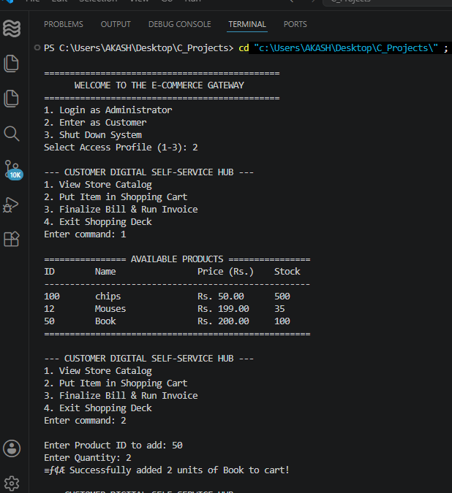

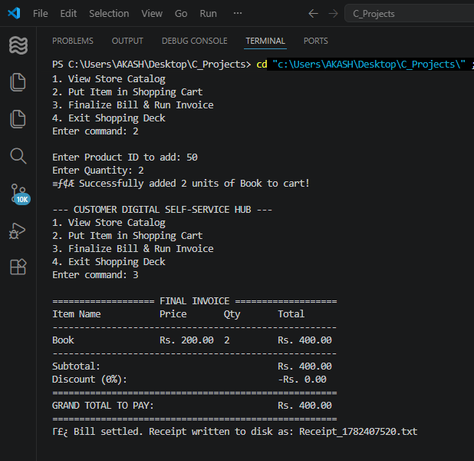
8. Project Analysis & Evaluation
Advantages:
• Dynamic Memory Scaling: Utilizes C++ STL vectors to allocate memory on demand, entirely eliminating the risk of fixed-array runtime overflows.
• Rigorous Inventory Control: Implements multi-factor checkout rules that instantly cross-reference stock levels to block invalid over-purchasing.
• Persistent Local Storage: Employs standard file streaming handling to guarantee that all database adjustments survive unpredictable system closures.
• Automated Tiered Incentives: Built-in pricing logic handles conditional calculations to instantly reward customer milestones with dynamic discounts
Limitations:
• Console Interface Constraints: The plain-text terminal interface restricts modern visual layouts and mouse-driven navigation for end-users.
• Volatile Session Storage: Customer shopping cart states reside strictly in volatile RAM, causing active baskets to wipe out if a crash occurs.
• Lack of Concurrent Safety: Standard flat-file database structures lack thread-safe locking properties, making concurrent file access risky.
• Hardcoded Credentials: Operational administrative credentials are statically written inside the source text rather than being safely hashed.
Future Enhancements:
• Graphical User Interface Integration: Incorporate robust desktop visual toolkits like Qt or wx Widgets to transition away from terminal frameworks.
• Relational Database Migration: Replace text files with SQLite or MySQL systems to enable scalable data handling and safer query processing.
• Network Gateway & API Processing: Integrate secure electronic banking modules alongside digital scanning hardware communication lines.
• Dynamic Multi-User Permissions: Build an encrypted, role-based login system supporting unique passwords hashed via cryptographic functions.
9. Conclusion
The Mini E-Commerce Product Billing System serves as an optimized, structurally sound architectural bridge that successfully merges core computer science data modelling tools with real-world enterprise deployment patterns. By consolidating essential Object-Oriented Programming (OOP) paradigms—such as standard structural encapsulation, access modifiers, and operational data isolation—the application proves how complex retail ecosystems can be modularized effectively. Furthermore, substituting restrictive static arrays with dynamic C++ Standard Template Library (STL) vector sequences demonstrates efficient memory management strategies crucial for modern software engineering.
The successful implementation of persistent file streaming streams ensures data integrity and operational permanence, showing how volatile runtime applications can securely sync changes to permanent disk layers. Although the platform is currently limited by its console-based interface, its underlying business logic, conditional tiered billing structures, and inventory validation checks are highly robust. Ultimately, this laboratory project stands as a resilient foundational framework that highlights the critical role of clean algorithm design, precise resource tracking, and automated logic in engineering real-world commercial software applications.
.

